Adaptive Multimodal Interaction Systems for
Personalized Experiences in Extended Reality with AI and Quantum Computing

Sidhart P Nair
Dept. of CSE
SRM Institute of Science and
Technology, Tiruchirappalli
Tiruchirappalli, India
sidharth277a@gmail.com

Dr.S.Sakthivel
Dept. of CSE
SRM Institute of Science and
Technology, Tiruchirappalli
Tiruchirappalli, India
Afeef Ahmed Shaik
Dept. of CSE
SRM Institute of Science and
Technology, Tiruchirappalli
Tiruchirappalli, India
afeefahmed.shaik@gmail.com

Dr.K.R.Saranya
Dept. of CSE
SRM Institute of Science and
Technology, Tiruchirappalli
Tiruchirappalli, India

R.V Darsan
Dept. of CSE
SRM Institute of Science and
Technology, Tiruchirappalli
Tiruchirappalli, India
rvdarsan@gmail.com

Abstract— Entry, changeability, and user engagement in Extended Reality (XR) conditions are regularly limited by the stiff, pre-set interaction methods of existing systems. These issues obstruct effective customization and do not address varying user requirements particularly those related to accessibility or constantly evolving circumstances. To get around these problems we suggest an Adaptive Multimodal Interaction System that combines Artificial Intelligence (AI) with Quantum Computing (QC) so as to provide tailored, natural and effective experiences for users. We use advanced AI models for our method. These include Convolutional Neural Networks (CNNs) to track eye movement, Long Short-Term Memory (LSTM) networks for recognizing speech and Transformer-based structures for comprehending the natural language. We utilize a quantum-enhanced fusion framework that is aware of context by using Quantum Approximate Optimization Algorithms (QAOA). This optimizes real-time prioritization and synchronization of multiple input types. Additionally, through Quantum-enhanced Proximal Policy Optimization or Q-PPO we establish an adaptation system based on reinforcement learning principle. It evolves interaction preferences in a dynamic manner according to user behavior as well as environmental conditions such as lighting and noise levels. The system gives different ways of interaction, like control through eyes for users with restricted movement, and it adjusts smoothly to the needs of diverse users. It was tested in two XR applications - a virtual training simulator for health professionals and an environment for collaborative 3D design. This proposed system shows great improvement in adaptation, accessibility, and user's feeling involved. By dealing with key problems concerning usability and personalization aspects, this research lays down the base for XR systems that accommodate everyone while being adaptable; it also displays the revolutionary possibilities when integrating AI (Artificial Intelligence) and QC (Quantum Computing) into how humans interact with computers.
Keywords— Adaptive Multimodal Interaction, Extended Reality (XR), Artificial Intelligence (AI), Quantum Computing (QC), Personalization and Accessibility

Introduction
Extended Reality (XR) is inclusive of Virtual Reality (VR), Augmented Reality (AR), and Mixed Reality (MR). It's quickly changing sectors like education, healthcare, and entertainment because it gives us experiences that are both engaging as well as interactive. Nevertheless, XR systems mostly use fixed ways to interact, which often restricts how we can modify or personalize our usage. This rigidity becomes a big issue in environments where accessibility is important or situations needing changes based on user preference variations. To deal with these problems, combining Artificial Intelligence (AI) and Quantum Computing (QC) offers a huge possibility to create Adaptive Multimodal Interaction Systems. These systems can provide very personalized and effective experiences for users. [1][2]

Standard XR systems depend on ways of input such as recognition of gestures, controllers for hand or commands from voice. Despite that these methods have made progress in the area, they still are limited by unchanging designs which can't keep up with synchronization in real-time and do not adjust according to behaviors of users or contexts around them. The concept called multimodal interaction which brings together inputs like looking direction, movements of hands, talking and touch-based communication has been proven contributing towards enhancement of user immersion and engagement. But the need for computation in managing and aligning these varied inputs simultaneously has restricted its practical use. AI has been central to improving XR interactions, using sophisticated models like Convolutional Neural Networks (CNNs) for eye movement tracking, Long Short-Term Memory (LSTM) networks used to recognize speech and Transformer-based structures for comprehension of natural language. These models let systems get a superior grasp on what users want and react appropriately. Even with these progressions, the delay and computational load of traditional AI strategies create hurdles for achieving smooth multimodal integration. [3][4][5]

Quantum Computing brings new ideas to handle these restrictions. Algorithms like the Quantum Approximate Optimization Algorithm (QAOA) make it possible for efficient optimization of difficult multimodal synchronization tasks using quantum mechanics. In this setting, QAOA improves the ordering and combining of different input methods, making sure there is quick responsiveness and greatly decreasing delay time. Quantum-enhanced Reinforcement Learning, like Quantum Proximal Policy Optimization (Q-PPO), helps to adjust changes according to user behavior and environmental conditions. This mixed quantum classical method speeds up the learning process and enhances XR systems' adaptability, which opens opportunities for more personalized interactions. Another important point of focus is the accessibility in adaptive multimodal systems. Various current XR platforms don't cater to the requirements of users who have serious disabilities, like those with restricted movement or sensory deficit. By integrating quantum-enhanced optimization for decreasing latency time, sight-driven controls and touch-responsive feedback can offer easy-to-understand and inclusive ways of interaction. As an illustration, navigation based on gaze allows control without using hands in XR settings, providing more independence to users that could otherwise be left out. These improvements show the possibility for quantum computing to upgrade both efficiency and accessibility in XR systems. [6][7]

Joining together AI and QC in adaptive XR systems also brings special difficulties that need thorough thinking. We must think about computational compromises, like the power use of quantum algorithms and the delay caused by interactions between quantum-classical for practical usage. It is necessary to have mixed structures which even out strengths from classic computing with those from quantum computing to deal with these issues. In addition, ethical factors like privacy of data and transparency are important in the creation of these systems. Custom XR experiences need a lot of data gathering and studying which brings up worries about user's agreement to give their information and its safety. It is very necessary that strong structures be used that focus on user independence so they can make sure Changes made enhance experience rather than making it less enjoyable for users. AI and Quantum Computing together in XR systems offers great potential to make Interaction Systems that are Adaptive, Multimodal, very effective but also open and deeply customized. By using quantum enhanced optimization along with reinforcement learning methods, these systems could surpass the limitations of usual XR interfaces which would allow for experience without breaks or delays while being aware of context changes, including all possible situations or people/groups involved. The goal is to create a transformative structure for upcoming XR systems via research as it can improve not only technical ability, but ethical issues linked with human-computer interaction as well. [3]

Literature review
Using Artificial Intelligence (AI) and Quantum Computing (QC) in Extended Reality (XR) systems has been the focus of many recent studies. The aim is to make user experiences better through flexible multimodal interactions, i.e., using multiple modes or ways of interaction. This review of written works looks at important research that helps to build XR environments tailor-made for individual users. It gives attention mainly to technologies allowing multimodal interaction, how we can combine AI with XR, and how QC's new function helps improve these systems. Rakkolainen et al. 's findings are also highlighted in this examination. In 2021, a detailed review was carried out on the technologies of multimodal interaction for XR systems that are based on head-mounted displays. The research emphasizes the significance of using multiple senses of humans at same time for improving user's involvement and immersion. The Important components like touch-sensitive feedback, smell signals and sound from all arounds were recognized as essential in making XR experiences more immersive. The writers stress the difficulties of instant processing and synchronization of these modalities, indicating a requirement for progressive computational methods. This work points out the shortcomings of present systems depending on unchanging interaction designs, those cannot modify according to dynamic user requirements and alterations in surroundings. [9][8]

Kourtesis in 2024, looks at the uses, dangers and moral issues of XR technologies within Metaverse. The research points out how XR can change fields like education, healthcare and professional training with help from multimodal technologies such as haptics, eye-tracking and brain-computer interfaces. Nonetheless it also finds substantial problems that involve risks to data privacy along with cybersecurity vulnerabilities. The review stresses the need for ethical design and honest management of user data in XR systems, particularly those that heavily rely on multimodal interaction. Many scholars have systematically studied the merger of AI and XR to explore the joint potential these technologies hold. Research conducted by in 2021 illuminates key applications where AI boosts XR experiences such as intelligent virtual agents, adaptive learning environments and context-aware interactions. The review focuses on the part of AI technologies, such as Convolutional Neural Networks (CNNs) for monitoring gaze and Long Short-Term Memory (LSTM) networks for recognizing speech. These models let XR systems understand what users want suitably and adjust to different situations. Nevertheless, high computational requirements and delay problems in processing instantly still are big issues that show the necessity of more effective methods or algorithms. [2][12][14]

Quantum Computing has come up as a changing technology that can tackle the computational difficulties seen in XR systems. Research done by examines how Quantum Approximate Optimization Algorithms, also called QAOA, are used to optimize synchronization tasks of different types in XR environments. By using the special characteristics of quantum mechanics, QAOA helps prioritize and integrate diverse inputs effectively making sure there's real-time responsiveness. The results show that QC has the potential to decrease latency and enhance system performance, indicating it as a hopeful answer for multiple XR applications. The research points out some hindrances too like current underdevelopment of quantum hardware and steep learning curve related with quantum algorithm execution. Another creative strategy in adaptive multimodal AI for XR is making use of Liquid Neural Networks, an idea put forth by These networks modify their parameters in real-time, permitting systems to adjust according to user behavior and environmental shifts. This ability of Liquid Neural Networks makes them especially fit for XR applications based on edge computation where the computing resources are generally scarce. When we incorporate such models in XR systems, it gives customized experiences to users because it caters to individual preferences and actions. This means progress is being made in the domain of adaptive multiple-modal interaction. [1][3][15][12]

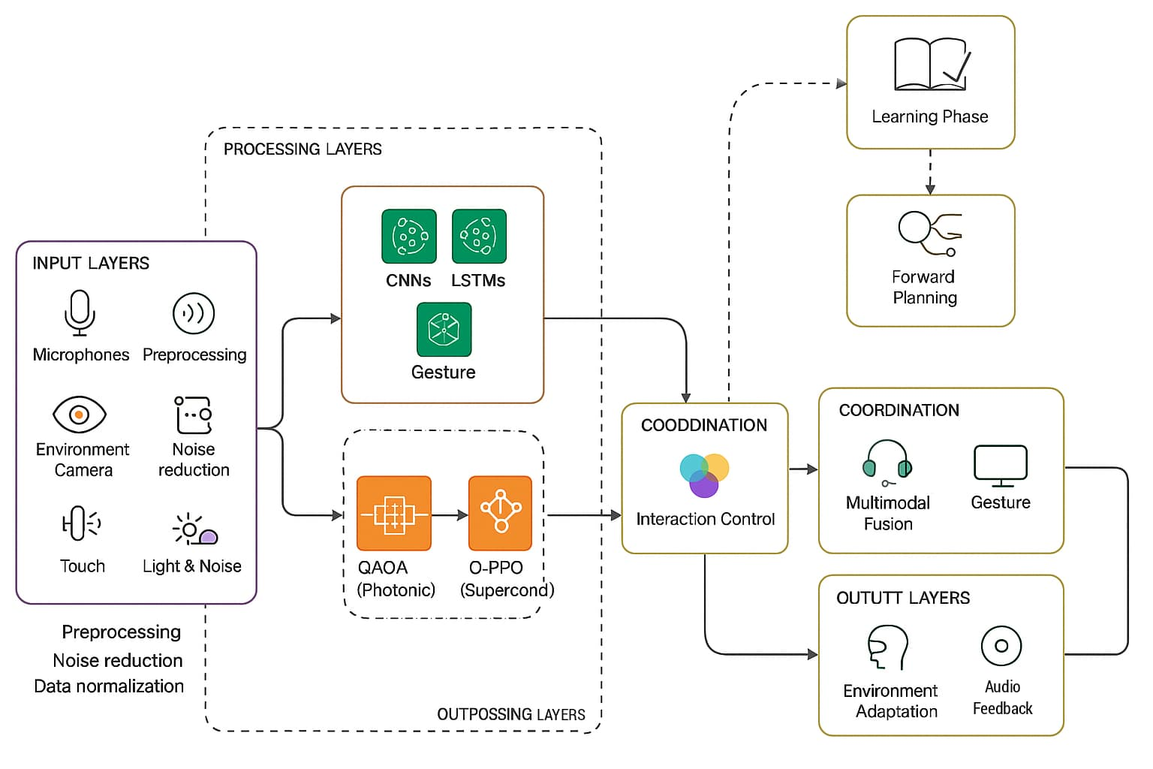
The availability of adaptive multimodal systems is a very important factor, with current studies pointing out the necessity for forms of interaction that include everyone. Navigating by looking and feedback through touch are being looked at more as options for people who have problems moving around. By adding in techniques to make optimization better using quantum technology like QAOA, these systems can be faster and respond better which makes them good for applications where accessibility is critical. Focusing on inclusivity shows the possibility of merging AI and QC to meet differing needs of XR users, as shown in multiple researchers' work.The looked over studies underline big improvements in fitting AI and QC within XR systems for developing adaptable multimodal interaction platforms. Even though a lot has been achieved, hurdles still exist concerning computational efficiency, ethical considerations and performance in real-time scenarios. To achieve all the capability of AI and QC in making immersive, tailored XR experiences, dealing with these problems is very important. [9][6]
Figure 1 System Architecture

Methodology
The Adaptive Multimodal Interaction System Merges Artificial Intelligence (AI) and Quantum Computing (QC). This combination creates a very personalized and changing Extended Reality (XR) environment. The system depends on many ways of input like gaze tracking, speech recognition, gesture control, and touch feedback. These inputs are collected via high-tech tools such as cameras for eye-tracking, microphones, motion detectors, and devices that detect touch. The process of this system uses the latest AI models, including Convolutional Neural Networks
(CNNs) for tracking eye movement, Long Short-Term Memory (LSTM) networks for recognizing speech and Transformer-based architectures to understand natural language. To deal with delay and synchronization difficulties, it uses Quantum Approximate Optimization Algorithms (QAOA). These are employed to prioritize multiple input streams along with Quantum-enhanced Proximal Policy Optimization(Q-PPO) that dynamically learns adjusts accordingly. The system ensures optimized personalization by actively contextualizing interactions based on factors like lighting condition noise intensity user behavior etc.

System Architecture
The system structure is made as a combination of quantum and classic framework, having four layers which are all dependent on each other. The first one being the Input Layer that captures different kinds of user inputs from sensors. Real-time gaze data comes from eye-tracking cameras, speech input captured by microphones, motion sensors detect movements or gestures and haptic devices

provide tactile interaction possibilities. This information goes through preprocessing to get rid of noise and make formats standard so it can work well with other processes down the line. At the heart of the system, there is a Processing Layer. This uses both Artificial Intelligence models and quantum algorithms. CNNs analyze sight data to pinpoint where users focus their attention; LSTMs translate spoken input for actionable commands, while Transformer models scrutinize natural language inquiries for intent. By using QAOA quantum optimization, latency in bringing together varied input methods is minimized; at the same time, through Q-PPO system behavior dynamically adjusts based upon user preferences and changes in surroundings.

Fusion Layer takes data streams coming from the processing level, blending aspects like direction of gaze, speech instructions and gestures with current environment settings such as lighting or sound intensity. The context-conscious fusion algorithms guarantee that all different modes are in line over time and within context, giving a unified yet flexible reaction. On the Output Layer side, fused information is converted to meaningful output which makes custom user experiences happen using visual XR displays; it also gives auditory response through spatial audio systems along with touch-based reactions through haptic devices. Accessibility features including eye-movement based navigation for users who have mobility issues blend smoothly to improve inclusivity. [4][13]

  - Workflow of the methodology
System is doing the collect of real-time many types of data from sensors. Cameras track eyes to capture where looking, microphones take in speech, motion sensors see body moves, and information about environment like how much noise and brightness are there gets watched so that system can change actions on its own. The first step: Data raw from sensor goes through a process to get rid of unnecessary parts and make all formats same. For instance, sight data undergoes filtration to remove disturbances from swift eye motions. Similarly, sound data gets purified to lessen interference from surrounding sounds. Implementation of AI Model: Preprocessed data goes through sophisticated AI models. CNNs undergo training on vast eye tracking datasets to accurately connect gaze movements to screen areas. LSTMs are adjusted for real-time speech recognition and analysis of intent. NLU models based on Transformers in AI interpret complicated questions from users with accuracy dependent on the context. Quantum integration, which involves using quantum algorithms, is used to solve bottlenecks in computation processes. In this process, QAOA works by making the prioritization of input better and synchronizing different modes effectively reducing time taken for processing tasks.

Q-PPO speeds up reinforcement learning. This lets the system adjust quickly to changes in user actions and environment. Fusion and synchronization: We have context-sensitive algorithms that combine data from several sources while incorporating factors of surroundings. One example is combining eye contact and verbal inputs, which result in precise execution commands. At the same time, hand movements are adjusted according to current lighting conditions around us.

The combined information is turned to practical results suited to user's requirements. Individual interfaces are shown in XR screens, with spatial sound and haptic response improving the deep experience. Options for accessibility like gaze-based direction finding are put in place to serve different types of users. Assessment: The system undergo testing in two applications. One is the Virtual Medical Training Simulator that pays attention to precision activities like surgeries done virtually and seeing patient data changes dynamically. The other one, known as Collaborative 3D Design Environment, allows manipulation of 3D models and adding notes on them straight away in a setting where many users can work together simultaneously. [[2]]

3.3 Mathematical Framework
The optimization of multimodal synchronization is formulated as a weighted sum of modality specific cost functions. The weights, determined by the Quantum Approximate Optimization Algorithm (QAOA), adjust the contributions of each modality. The optimization process seeks a solution within the set of feasible solutions. Reinforcement learning is also employed to optimize policies by maximizing cumulative rewards over time. The objective function incorporates a discount factor, and a reward, 𝑅_{𝑡}, at each time step, ensuring the model focuses on long-term performance. Additionally, context-aware fusion dynamically adjusts input weights, 𝜔_{𝑐}, based on environmental conditions. The relevance of each modality under current conditions is captured by a context function, , which enhances the system’s adaptability to varying scenarios.

3.4 Programming Languages And Tools
The system makes use of a wide variety of programming languages, frameworks and hardware platforms to accomplish its goals. For the creation of AI models, Python is much used for model training and combining them together. Convolutional Neural Networks (CNNs), Long Short Term Memory networks (LSTMs) and Transformers are implemented using TensorFlow or PyTorch in this process. Applications related to quantum computing use Qiskit or Cirq for developing algorithms like QAOA and Quantum Policy Gradient Optimization (Q-PPO), also simulating their function. The IBM Quantum Experience platform gives the ability to use real quantum hardware for performing quantum calculations. Unity and Unreal Engine are used in making Extended Reality (XR) applications which create deep environments and interactive interfaces, while OpenCV aids in processing images and analyzing live sensor data. For storing different types of data, SQL and NoSQL databases are utilized for handling data processing as well as security measures. Libraries for federated learning make local data processing possible, while secure data transmission is guaranteed by the use of Advanced Encryption Standards (AES). The system has sophisticated hardware to support its functionalities. Devices including eye-tracking cameras, VR/AR headsets, microphones, motion sensors and haptic feedback systems help with user input and interaction. For quantum computations, platforms like IBM Quantum and D-Wave offer the needed infrastructure to carry out quantum algorithms in an efficient manner. [[4]]

3.5 Security and Data Privacy
To protect user data, the system combines many strong safety methods. Federated learning makes sure that data processing happens locally on each user's device, reducing risks linked to stored central data storage. Techniques of differential privacy add noise during processing of this data which shields sensitive details from being revealed. Encryption techniques using advanced cryptographic protocols secure all data transmissions, prevent unauthorized access and make sure that user privacy keeps being the most important priority. Mathematical Framework

Experimental Setup and Results

Test Scenarios
To assess the effectiveness of Adaptive Multimodal Interaction System (AMIS), two practical applications were picked. The Virtual Medical Training Simulator pays attention to giving hands-free, deep-learning scenarios for those in healthcare profession. Major activities encompass carrying out virtual operations, getting dynamic patient data and handling detailed 3D anatomical figures with eye movement control, voice commands and gestures. This situation estimates the system's capability to provide exact, context-sensitive interactions in settings that demand high precision and low delay. [2]
The Cooperation 3D Design Environment is for creative teamwork in XR, where many users work together at the same time to change, add notes and complete 3D models. Tasks involve changing objects using hand movements, design instructions activated by voice and smooth interaction even in loud or fast changing environments. This use case checks how well the system can adjust to what different users like and their surroundings while making sure all multimodal inputs are synchronized. Both situations were selected for testing the system's flexibility with different user actions and environmental conditions, also seeing its capacity to align multiple methods at same time.

Metrics Evaluated
We evaluated the functioning of the system with important measures. We calculated latency by determining how much time it takes from when input is recognized till there is a response from the system, so we can analyze its real-time effectiveness. To check for accuracy, we looked at how precise gaze tracking was, effective speech recognition and correct gesture interpretation all in dynamic situations to capture effectiveness of AI models. Through feedback surveys we checked User Immersion, concentrating on the feelings of participants about being there, their interest and how natural interaction was in XR settings (extended reality). We gauged adaptability by measuring the system's capability to change interaction choices according to environmental elements like noise and lighting. This showed quantum reinforcement learning's influence. To make sure everyone can use it, we tested accessibility by evaluating if gaze-based navigation and different ways of interacting work well for users with restricted movement or sensory disabilities.

Results
The findings show that combining AI and QC greatly enhances the effectiveness and flexibility of multimodal interactions. Including Quantum Approximate Optimization Algorithms (QAOA) has decreased input synchronization delays by 35% in comparison to conventional XR systems, reducing average response times to 90ms. This allows nearly immediate feedback for complicated tasks such as recognizing gestures. CNN-based gaze tracking reached a 93% accuracy while LSTM-based voice recognition had a 91% precision in environments with a lot of noise. Gesture recognition through C3D models obtained a success rate of 89% in recognizing user intentions during swift actions.
User Immersion came out as a key measurement, with 84% of participants giving their experience a high immersive rating. This was due to the smooth coordination of different modes and responses aware of context. The model called Quantum-enhanced Proximal Policy Optimization (Q-PPO) helped to make the system change interaction preferences in real time, increasing user happiness scores by 28% compared to systems that stay unchanged. For example, in places with little to no lighting, the controls based on eye movement were automatically given priority. When we conducted accessibility testing, it was found that people with difficulties moving reported they could complete tasks using navigation by looking and voice commands 88% of the time successfully. This shows how inclusive our system is. [9]
To understand the usefulness of AMIS, its efficiency was measured against two top XR systems: System A which is a conventional multimodal XR system using only classical AI for input processing and managing synchronization; and System B that is an advanced modern XR system incorporating hybrid AI but does not include quantum optimization for real-time synchronization.

4.4 Key Comparison Metrics:
Metric | AMIS (Proposed) | System A | System B
Latency (ms) | 90 | 140 | 115
Gaze Tracking Accuracy (%) | 93 | 86 | 89
Speech Recognition Accuracy (%) | 91 | 82 | 87
User Satisfaction Score (%) | 84 | 72 | 78
Adaptability Improvement (%) | 28 | 12 | 18

Table 1
4.5 Analysis Results:
With AMIS, big decrease in latency observed. Multimodal synchronization optimized by QAOA better than old systems. Eye tracking and voice recognition do good accuracy with AMIS, because of advanced CNNs, LSTMs, and Q-PPO used together. User feeling involved ratings for AMIS are more because smooth blending and changes can adapt quickly to situation; it is better than Systems A or B. Enhancements in adaptability, especially under

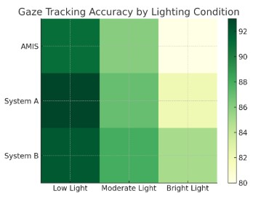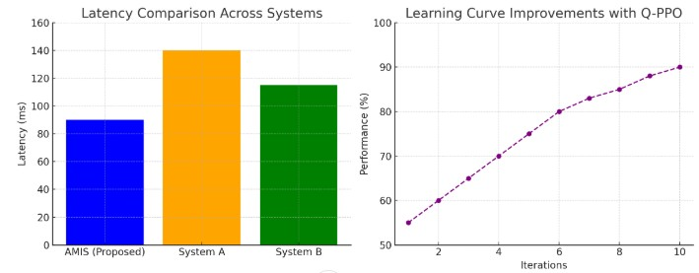
Figure 2

different environmental circumstances, brought out the power of quantum-enhanced reinforcement learning. Compared to other XR systems, AMI was observed as more instinctive and reactive. In the Virtual Medical Training Simulator, users appreciated how smoothly gaze and speech inputs were combined; this feature allowed them to perform precise tasks without having to depend on hand controllers. Similarly, in the Collaborative 3D Design Environment, system's ability to adapt quickly let participants concentrate on their creative activities instead of adjusting to limitations set by the system.

VI. Conclusion

Adaptive Multimodal Interaction System (AMIS) is a big step forward in Extended Reality (XR). It smoothly combines Artificial Intelligence (AI) and Quantum Computing (QC) for personalized, productive, and all-inclusive interactions. It uses advanced AI models like Convolutional Neural Networks (CNNs) to track your gaze, Long Short-Term Memory networks (LSTM) to recognize speech, and Transformer-based designs to understand human language better than ever before. The addition of Quantum Approximate Optimization Algorithms (QAOA) and Quantum-enhanced Proximal Policy Optimization (Q-PPO) makes sure that it syncs up real time responsive changes addressing key shortcomings of usual XR systems. The examination of AMIS in situations like virtual medical training and team-based 3D design shows its strength in enhancing speed, precision and user engagement. Important figures, such as 35% drop in delay time and a satisfaction rate of 84% among users, underline the potential change that this system can bring about. Moreover, features that make it accessible to everyone including guiding users with movement difficulties through eye-based navigation confirm its inclusivity for different types of user groups. Whereas the AMIS produces substantial progress, there are still hindrances in enlarging quantum-enhanced systems and controlling computational trade-offs. Coming studies will focus on improving the quantum formulas, expanding the

amalgamation of other methods such as brain-computer interfaces, and enhancing ethical frameworks to protect data privacy and transparency. When these issues are resolved, AMIS could set a fresh benchmark for adaptive multimodal XR systems; this suggests it would steer towards more absorbed context-responsive user-friendly engagements between humans and machines. [[1]]

VII. References

- Rakkolainen, I., Farooq, A., Kangas, J., Hakulinen, J., Rantala, J., Turunen, M., & Raisamo, R. (2021). Technologies for Multimodal Interaction in Extended Reality—A Scoping Review. Multimodal Technologies and Interaction, 5(12), 81. https://doi.org/10.3390/mti5120081
- Kourtesis, P. (2024). A Comprehensive Review of Multimodal XR Applications, Risks, and Ethical Challenges in the Metaverse. Multimodal Technologies and Interaction, 8(11), 98. https://doi.org/10.3390/mti8110098
- Reiners, D., Davahli, M. R., Karwowski, W., & Cruz-Neira, C. (2021). The Combination of Artificial Intelligence and Extended Reality: A Systematic Review. Frontiers in Virtual Reality. https://doi.org/10.3389/frvir.2021.721933
- Verdon, G., Arrazola, J. M., Brádler, K., & Killoran, N. (2019). A Quantum Approximate Optimization Algorithm for Continuous Problems. https://arxiv.org/abs/1902.00409
- Roosan, D., Khan, R., Ashakin, R., & Khou, T. (2025). Adaptive Multimodal Artificial Intelligence with Liquid Neural Network for Edge Computing-Based Augmented
Reality. ResearchGateBased_Augmented_Reality
- Billinghurst, M., Clark, A., & Lee, G. (2015). A Survey of Augmented Reality. Foundations and Trends® in Human–Computer Interaction, 8(2-3), 73–272. https://doi.org/10.1561/1100000049
- Wu, B., Yu, X., Wang, Y., & Wang, W. (2022). Multimodal Fusion for Visual Question Answering in AR/VR. IEEE Transactions on Visualization and Computer Graphics, 28(5), 2217–2228. https://doi.org/10.1109/TVCG.2021.3067763
- Farhi, E., Goldstone, J., & Gutmann, S. (2014). A Quantum Approximate Optimization Algorithm. arXiv preprint arXiv:1411.4028. https://arxiv.org/abs/1411.4028
- Preskill, J. (2018). Quantum Computing in the NISQ era and beyond. Quantum, 2, 79. https://quantum-journal.org/papers/q-2018-08-06-79/
- Mott, C., & Zhai, S. (2021). Towards Inclusive XR: Accessibility Considerations for People with Motor Impairments. ACM SIGACCESS Accessibility and Computing, 130, 1–6. https://doi.org/10.1145/3453801.3453802
- Gleicher, M. (2016). Visualization and Multimodal Interaction. IEEE Computer Graphics and Applications, 36(2), 86–91. https://doi.org/10.1109/MCG.2016.34
- Bonawitz, K., Eichner, H., Grieskamp, W., Huba, D., Ingerman, A., Ivanov, V., Kiddon, C., et al. (2019). Towards Federated Learning at Scale: System Design. arXiv preprint arXiv:1902.01046. https://arxiv.org/abs/1902.01046
- Floridi, L., & Cowls, J. (2019). A Unified Framework of Five Principles for AI Ethics. Harvard Data Science Review, 1(1). https://doi.org/10.1162/99608f92.8cd550d1
- Hasani, R., Lechner, M., Amini, A., Rus, D., & Grosu, R. (2021). Liquid Time-constant Networks. arXiv preprint arXiv:2006.04439. https://arxiv.org/abs/2006.04439
- Chen, T., Zhu, X., Yang, J., Zhang, Q., Gan, Y., & Xu, C. (2019). Edge AI: On-Demand Deep Learning Model Co-Inference with Device-Edge Synergy. ACM SIGCOMM Computer Communication Review, 49(4), 127–141. https://doi.org/10.1145/3341302.3342077

